**CLOUD ARCHITECTURE**

**CONTENT:**

**Introduction**

**Vision and Scope**

**Cloud Architecture Design**

**Pipeline Strategy**

**Conclusion**



**INTRODUCTION:**

Welcome to ShopCom, our ultimate destination for online shopping and trendsetting. At ShopCom, we redefine the e-commerce experience by offering a seamless platform where customers can discover the latest trends and create their unique style statements. Our name reflects our commitment: "Shop" signifies the ease with which anyone can explore and buy, and "Com" represents our dedication to customer order management, ensuring a smooth and personalized shopping journey for all.

**VISION AND SCOPE:**

* At ShopCom, our vision is to revolutionize the way people shop online.
* We aim to be the leading trendsetter in the e-commerce industry, empowering individuals to express themselves through fashion and lifestyle products.
* Our focus extends beyond just selling goods; we aspire to cultivate a vibrant community where creativity thrives and new trends emerge.
* To realize our vision, ShopCom leverages state-of-the-art cloud architecture and cutting-edge pipeline strategies.
* Our cloud infrastructure ensures scalability, security, and reliability, enabling us to handle increasing customer demands efficiently.
* We employ advanced data pipelines and analytics to understand customer preferences and deliver personalized recommendations, enhancing the overall shopping experience.

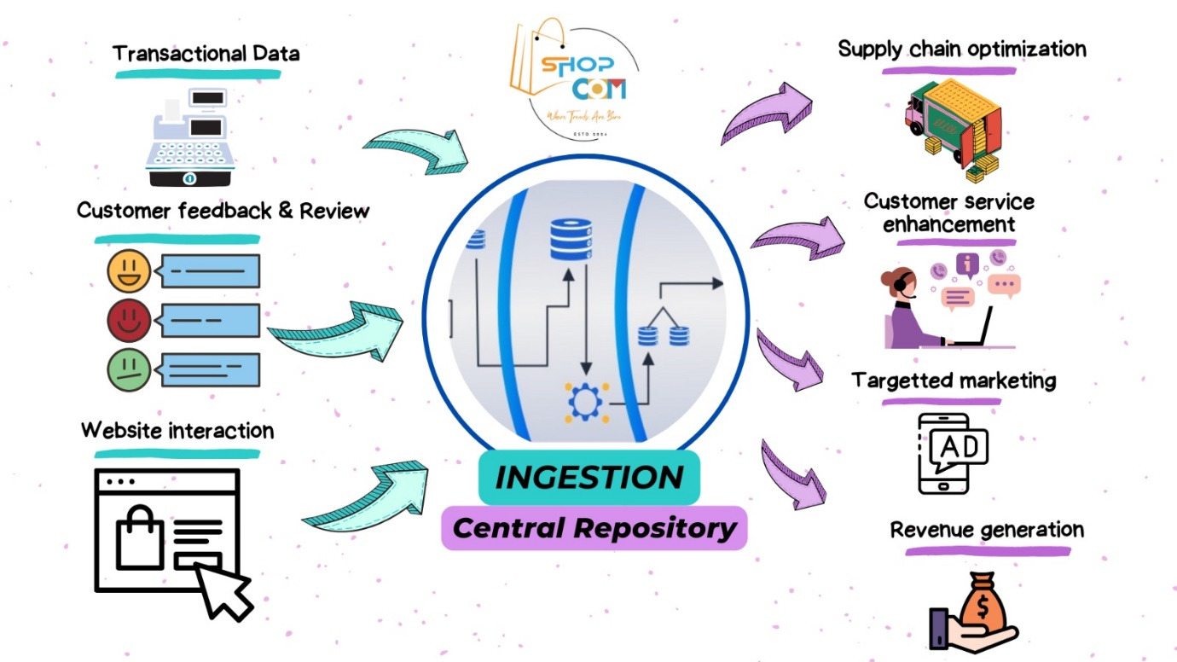

The vision is to create a comprehensive e-commerce platform that seamlessly manages customer databases, tracks inventory, processes orders, and provides analytics and visualizations for informed decision-making.

**CLOUD ARCHITECTURE DESIGN:**

Proposed CloudArchitecture

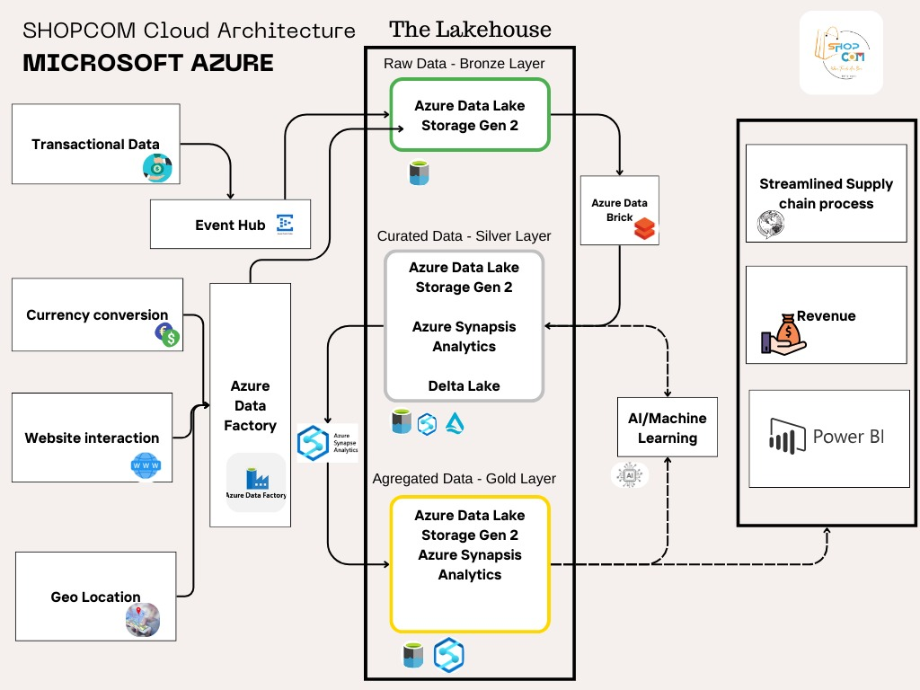

The cloud architecture of the e-commerce platform involves hosting its databases, applications, and services on cloud platforms like AWS, Azure, or Google Cloud. This ensures scalability, flexibility, and accessibility while maintaining data security. It enables real-time insights and collaboration among stakeholders.

Benefits of moving to the cloud for e-commerce:

* Enhanced performance and efficiency as the platform can dynamically scale resources based on traffic spikes and demand fluctuations.
* Improved accessibility, allowing customers to access the website from various devices and locations, enhancing user experience and customer satisfaction.
* Lower IT costs by eliminating the need for on-premises infrastructure, reducing hardware maintenance expenses, and paying only for the resources used.
* Increased flexibility and reliability, with cloud platforms offering robust infrastructure, automatic backups, and disaster recovery solutions to ensure uninterrupted service availability and data integrity.

**PIPELINE STRATEGY:**

* Data Ingestion: Data ingestion is the initial step in the data management pipeline where data is collected from diverse sources. This process involves identifying the sources, extracting data, transforming it into a structured format, and loading it into a target destination. Data can be ingested through batch processing, real-time streaming, or event-driven mechanisms, depending on the requirements of the organization.
* Data Curation: Data curation focuses on ensuring the quality, consistency, and reliability of the ingested data. It involves assessing data quality, standardizing formats, cleansing inconsistencies, and enriching with additional context. Data curation also includes establishing governance policies and procedures to manage data assets effectively, ensuring data security, compliance, and access control.
* Data Aggregation: Data aggregation involves consolidating and summarizing data from multiple sources to derive insights and support decision-making. This process includes integrating disparate datasets, summarizing data at different levels of granularity, and visualizing insights through dashboards and reports. Aggregated data provides a comprehensive view of organizational data assets, enabling stakeholders to analyze trends, identify patterns, and make informed decisions.

Top of FormAs a pipeline strategy, Data collection is done by Event Hub and Azure Data Factory. Azure Databricks is utilized between the Bronze and Silver layers in the data brick line to facilitate the transition from raw, unstructured data to curated, standardized data. In the Bronze layer, data is ingested from various sources in its raw form. Azure Databricks then processes this data, performs transformations, and applies quality control measures to refine it into a structured format, representing the Silver layer. This platform enables efficient data engineering, cleansing, and standardization processes, laying the groundwork for advanced analytics and decision-making. By leveraging Azure Databricks, organizations can streamline their data management workflows and derive actionable insights from their data assets more effectively.

Azure Synapse Analytics plays a crucial role between the Silver and Gold layers in the data brick line by facilitating advanced analytics and insights generation. In the Silver layer, curated and standardized data is prepared for analysis and decision-making. Azure Synapse Analytics then takes this refined data and performs complex analytics, data mining, and machine learning tasks to uncover valuable insights. By leveraging its capabilities for data warehousing, big data processing, and real-time analytics, Azure Synapse Analytics empowers organizations to derive actionable insights from their data assets and drive strategic decision-making in the Gold layer. This platform provides a scalable and integrated environment for analytics workloads, enabling organizations to unlock the full potential of their data and accelerate innovation.

**CONCLUSION:**

* The scalability offered by cloud databases ensures that we can effortlessly accommodate the growth of our data volumes and user base without the need for significant upfront investments or complex infrastructure management.
* Built-in redundancy and automated failover mechanisms - maintain uninterrupted access to our data, safeguarding business continuity and preserving customer trust.
* The flexibility afforded by cloud databases enables us to adapt quickly to changing business requirements and technological advancements.
* Security -features such as encryption, access controls, and regular audits can mitigate risks and ensure regulatory compliance, thereby enhancing our credibility and trustworthiness in the eyes of our stakeholders.

Bottom of Form